**V KEYBOARD**

**A PROJECT REPORT**

***Submitted by***

**ABHISHEK K**

**ARJHUN M**

**VASIGARAN S**

**ARULLANANDH**

***in partial fulfillment for the award of the degree***

***of***

**BACHELOR OF ENGINEERING**

**IN**

ELECTRONICS AND COMMUNICATION ENGINEERING

**PSG INSTITUTE OF TECHNOLOGY AND APPLIED RESEARCH, COIMBATORE**

**ANNA UNIVERSITY: CHENNAI 600 025**

MAY 2018

**ANNA UNIVERSITY: CHENNAI 600 025**

**BONAFIDE CERTIFICATE**

Certified that this project report “**V Keyboard**” is the bonafide work of  **ABHISHEK K ARULLANANDH ARJHUN M VASIGARAN S** who carried out the project work under my supervision.

ABSTRACT:

The keyboard acts as the key input device of computer and other smart electronic devices. The next generation of keyboards is virtual keyboards which don’t have mechanical keys but functions effectively the same purpose using gesture recognition. The aim of our project is to design and implement an effective virtual keyboard. The virtual keyboard will require only air typing for entering the input rather than the typical mechanical key presses. The input module is cubical with array of lasers aligned exactly opposite to light dependent resistors. The interruption of the laser light by the human fingers for entering input is mapped to match the character to be pressed. Our virtual keyboard uses NI MY Rio as the microcontroller to which the coding is dumped from lab view. NI MY Rio will identify the character that is pressed and send the data to the console on the lab view for display.

VIRTUAL KEYBOARD

INTRODUCTION

Technology is scaling at a very faster rate. From time to time, Human-Computer interaction is improved for the purpose of simplifying human lives. Hand held devices have become a part of our day to day life. Among them, Keyboard remains a major kind of input device for computer and other smart electronic devices. As the key input device of computer and in achieving Human-Computer interaction, keyboard plays an irreplaceable role in many areas for data input so that we can look at the output screen to interpret the output data. However, traditional keyboards are too bulky and are inconvenient to carry. In addition to that the traditional keyboards offer very little scope in terms of enhancement. The size of laptops and desktops are becoming smaller in this age of miniaturization. Also the traditional keyboards act as a hindrance to further miniaturization. Moreover the traditional ones have a major drawback in the form of wear and tear, when used for a very long time.

Hence instead of using conventional keyboards, the demand for an intuitive, immersive and cost-efficient interaction device has arisen. The Virtual keyboard is a perfect solution. Virtual keyboards may be used in some cases to reduce the risk of [keystroke logging](https://en.wikipedia.org/wiki/Keystroke_logging). For example, [Westpac](https://en.wikipedia.org/wiki/Westpac)’s online banking service uses a virtual keyboard for the password entry, as does [TreasuryDirect](https://en.wikipedia.org/wiki/TreasuryDirect). It is more difficult for [malware](https://en.wikipedia.org/wiki/Malware#Data-stealing_malware) to monitor the data entered via the virtual keyboard, than it is to monitor real keystrokes. Thus it is difficult to spy on the data entered by users. In this project, a virtual keyboard implementation of that kind is presented.

The approach towards the development of the virtual keyboard, abandons the concept of the physical keyboard in its traditional way. On the other hand, in pursuit of a new conceptual keyboard, the full functionalities of its counterparts should be preserved and processing capabilities should not be compromised for the sake of compactness.

In this paper, the virtual keyboard system combines laser, Light dependent resistors with NI My Rio processor. Different from brain-computer interface, special gloves and other methods, visual-based virtual keyboards do not require redundant equipment to wear, and keep small in size, thus it has broader future.

The virtual keyboard that we have developed is a laser keyboard and it has no physical buttons. And placing the finger in the paths of laser light implies the pressing of keys. This device can be programmed to display letters of any language and this is possible with the mapping of the letters of the language to the laser presses. Thus the virtual keyboard acts a multiple language insertion device. It includes numbers, letters, modifying keys and special characters. The virtual text entry system is actually air typing to enable users engage effortlessly during typing.

Literature survey:

Various new techniques have been adopted on the design schemes of virtual keyboard such as computer interaction based on laser and image processing[1], gesture recognition [2] and brain-computer interface[4]. Reference [1] developed a virtual keyboard where keystroke can be detected accurately by image processing including morphology principle and ellipse fitting. In case of reference[1], Keyboard pattern is projected on the horizontal plane by the projector, forming input virtual keyboard layout that allows users to "press key". In normal indoor lighting conditions, the projection technology can clearly project full-size keyboard pattern on any plane, allowing users to operate and type as easy as a traditional keyboard. Reference [2] demonstrates the realisation of virtual keyboard utilising IR proximity sensing system and keystroke recognition with k-NN and MLP neural networks. Unfortunately in the Reference [2] experiments, the finger had to be held perpendicular to the surface of the keyboard. This is obviously an unwanted feature. An arbitrary quadrangle-shaped panel (e.g., an ordinary piece of paper) and a tip pointer (e.g., fingertip) as an intuitive, wireless and mobile input device is employed in [3]. In [3], the panel tracking continuously determines the projective mapping between the panel at the current position and the display, which in turn maps the tip position to the corresponding position on the display. By detecting the clicking and dragging actions, the system can fulfil many tasks such as controlling a remote large display, and simulating a physical keyboard. In [5], an asynchronously controlled three-class brain-computer inter- face-based spelling device virtual keyboard, operated by spontaneous electroencephalogram and modulated by motor imagery. At the same time in [5], multiple classes and asynchronous control can limit the usability of the system. Users do require more training and the cognitive load is higher. The system in [6], consists of a pattern projector and a true-3D range camera for detecting the typing events. It exploit depth information acquired with the 3D range camera and detect the hand region using a pre-computed reference frame. The fingertips are found by analyzing the hands' contour and fitting the depth curve with different feature models. In [6], a virtual key board based on a true-3D optical ranging is presented. It is accurate and robust; however it requires a 3D optical imaging system. In [7], a Multi-Level Feature Matching (MLFM) method is presented for 3D hand posture reconstruction of a virtual keyboard system. The human hand is modeled with a mixture of different levels of detail, from skeletal to polygonal surface representation. Different types of features are extracted and paired with the corresponding model. The matching is performed in a bottom-up order by SCG optimization with respect to the state vector of motion parameters. The low level of matching provide initial guess to the high level of matching, refining the precise position of the hand hierarchically. Reference [8] discusses a new portable and noninvasive eye-trackers allow the creation of robust virtual keyboards that aim to improve the life of disabled people who are unable to communicate. The virtual keyboard is based on a menu selection with eight main commands that allow us to spell 30 different characters and correct errors with a delete button.

In [9], [10], the systems provide special features such as hand gestures and multi – touch but [9] requires multiple cameras. In [11], the shadow of a finger is detected, and when it is occluded by the finger, a touch is assumed. The corresponding touch detection system created in [12] was designed to detect a touch by comparing the ratio of black pixels to the number of white ones. It is understood that in the corresponding article [12], the ratio is acquired by searching small regions around the fingertips and comparing the number of white pixels to black ones, where black pixels represent the shadow. If the ratio of white to black pixels exceeds a certain threshold, a touch has occurred. However these methods are sensitive to the direction of lighting, where in many cases only a thin portion of the shadow is captured by the camera. Therefore, when the finger seems close to touching the surface, it is still far away from it, since the pixel difference is small. In [13] and [14], high speed camera is used, and a special in-air movement should be made. Reference [15] employs the principle of particular correspondence between sensor state and symbol, where each independently movable finger joint activates its own sensor, with a substrate in the form of glove to associate all these numerous sensors. In the case of Reference [19], digital image processing methods are being used, such as binarization, morphological operation and filtering. Real time image acquisition is performed by a mid-range quality web camera in order to identify the method of simultaneous fingertip and keyboard character recognition in order to produce a fully functional keyboard for user input. Reference [20] describes the design, implementation and evaluation of a text input system for HMDs called Air Typing, which requires only a standard camera and is shown to be comparable in effectiveness to single-hand text input on tablet computers in a lab setting. Air Typing features a novel two-level virtual keyword layout, which substantially improves the typing speed by cutting down unnecessary hand movements during typing and greatly simplifies the associated image processing task by doing away with fine-grained matching between fingertips and keys.

PRINCIPLE OF PROPOSED VIRTUAL KEYBOARD

Laser diodes are placed in a matrix fashion and the light from the lasers are made to intersect at their respective rows and columns. The end point of these laser will be the light dependent resistors. So when the light falls on the light dependent resistor (LDR) the value obtained across the LDR will be higher than predetermined threshold 3 volts, hence the value is treated as digital high and when the laser is blocked by any object, then the value at the LDR will be less than 3 volts, so the value is treated as digital low. When the human hands are intercepted between any intersections of the laser matrix, a respective key will be pressed and in this way multiple keys can be mapped to the multiple intersections of the laser matrix.

Since laser have very high frequency around 4*1014 Hz, it can be said that there will only be minute interference or no interference at all. So it is assured that the components will work at all times without any faults.

SYSTEM ARCHITECTURE

Virtual keyboard system mainly consists of two modules: an input module with laser and LDR and a processing module containing NI MY RIO processor. Fig 1.1 shows virtual keyboard system architecture.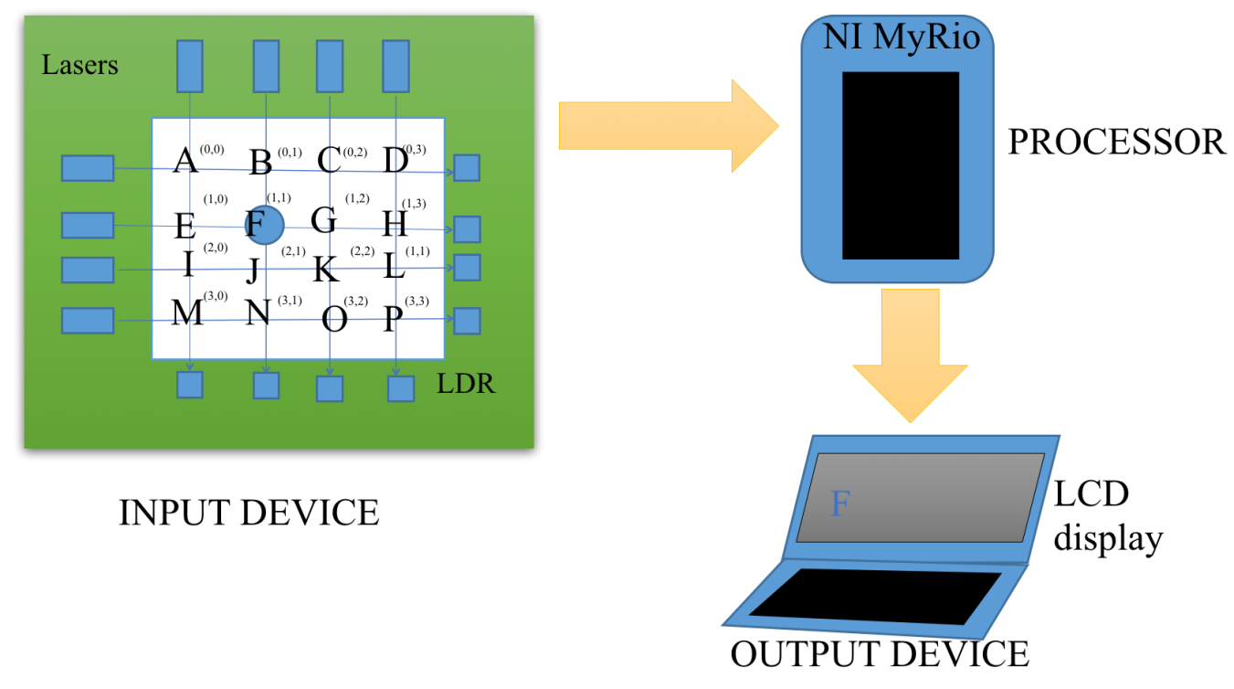

INPUT MODULE

The core components used in this input module includes laser diodes and Light Dependent Resistors (LDR’s). The keyboard module was built by 3d printing. 3D printing refers to processes in which material is joined or solidified under computer control to create a [three-dimensional](https://en.wikipedia.org/wiki/Three-dimensional_space) object, with material being added together (such as liquid molecules or powder grains being fused together). 3D printing is used in both rapid prototyping and additive manufacturing (AM). Objects can be of almost any shape or geometry and typically are produced using digital model data from a [3D model](https://en.wikipedia.org/wiki/3D_modeling) or another electronic data source such as an [Additive Manufacturing File](https://en.wikipedia.org/wiki/Additive_Manufacturing_File_Format) (AMF) file (usually in sequential layers). Stereo lithography (STL) is one of the most common file types that is used for 3D printing. Thus, unlike material removed from a stock in the conventional machining process, 3D printing or AM builds a three-dimensional object from computer-aided design (CAD) model or AMF file, usually by successively adding material layer by layer. Before printing a 3D model from an [STL](https://en.wikipedia.org/wiki/STL_(file_format)) file, it must first be examined for errors. Most [CAD](https://en.wikipedia.org/wiki/Computer-aided_design) applications produce errors in output STL files of the following types:

1. Holes

2. faces normals

3. Self-intersections

4. Noise shells

5. Manifold errors

The necessity for 3d printing arises for the sake of better accuracy and finishing. Moreover 3d printing model replicas don’t show discrepancies in the form of dimensions. The modelling is done with the help of cube pro software. The modelling material is Red PLA or poly lactic acid, organic thermoplastics*.* PLA will give the product better structural integrity and will be more suited to mechanical use given the material can better withstand the elements. It also offers a shinier and smoother appearance.

The model is cuboid in shape with one of the faces left open and the rest are covered. There are 14 tiny holes on each of the two longer faces of the cuboid. There are 5 similar holes on the each of the smaller faces of the cuboid. The holes at the faces of the modelled material are to aid the insertion of lasers and LDR’s. The positions of the holes are precise such that the parallel holes are aligned in a straight line.

The dimensions of the 3d printed material are as follows:

The REES52 Red laser diodes, with a 650nm red wavelength are used. They can be driven from 5V.

A laser is a device that emits [light](https://en.wikipedia.org/wiki/Light) through a process of [optical amplification](https://en.wikipedia.org/wiki/Optical_amplification) based on the [stimulated emission](https://en.wikipedia.org/wiki/Stimulated_emission) of [electromagnetic radiation](https://en.wikipedia.org/wiki/Electromagnetic_radiation). The term "laser" originated as an [acronym](https://en.wikipedia.org/wiki/Acronym) for "light amplification by stimulated emission of radiation”.

A laser consists of a [gain medium](https://en.wikipedia.org/wiki/Active_laser_medium), a mechanism to energize it, and something to provide optical [feedback](https://en.wikipedia.org/wiki/Feedback). The gain medium is a material with properties that allow it to [amplify](https://en.wikipedia.org/wiki/Optical_amplifier) light by way of stimulated emission. Light of a specific wavelength that passes through the gain medium is amplified (increases in power).

For the gain medium to amplify light, it needs to be supplied with energy in a process called [pumping](https://en.wikipedia.org/wiki/Laser_pumping). The energy is typically supplied as an electric current or as light at a different wavelength. Pump light may be provided by a [flash lamp](https://en.wikipedia.org/wiki/Xenon_flash_lamp) or by another laser.

The most common type of laser uses feedback from an [optical cavity](https://en.wikipedia.org/wiki/Optical_cavity)which is a pair of mirrors on either end of the gain medium. Light bounces back and forth between the mirrors, passing through the gain medium and being amplified each time. Typically one of the two mirrors, the [output coupler](https://en.wikipedia.org/wiki/Output_coupler), is partially transparent. Some of the light escapes through this mirror. Depending on the design of the cavity (whether the mirrors are flat or [curved](https://en.wikipedia.org/wiki/Curved_mirror)), the light coming out of the laser may spread out or form a narrow [beam](https://en.wikipedia.org/wiki/Light_beam). In analogy to [electronic oscillators](https://en.wikipedia.org/wiki/Electronic_oscillator), this device is sometimes called a laser oscillator.

STIMULATED EMISSION

When an electron absorbs energy either from light ([photons](https://en.wikipedia.org/wiki/Photon)) or heat ([phonons](https://en.wikipedia.org/wiki/Phonon)), it receives that incident quantum of energy. But transitions are only allowed in between discrete energy levels. This leads to [emission lines](https://en.wikipedia.org/wiki/Emission_line) and [absorption lines](https://en.wikipedia.org/wiki/Spectral_line).

When an electron is [excited](https://en.wikipedia.org/wiki/Excited_state) from a lower to a higher energy level, it will not stay that way forever. An electron in an excited state may decay to a lower energy state which is not occupied, according to a particular time constant characterising that transition. When such an electron decays without any external influence, emitting a photon, that is called "[spontaneous emission](https://en.wikipedia.org/wiki/Spontaneous_emission)". The phase associated with the photon that is emitted is random. A material with many atoms in such an excited state may thus result in [radiation](https://en.wikipedia.org/wiki/Radiation) which is very spectrally limited, but the individual photons would have no common phase relationship and would emanate in random directions. This is the mechanism of [fluorescence](https://en.wikipedia.org/wiki/Fluorescence) and [thermal emission](https://en.wikipedia.org/wiki/Thermal_emission).

An external electromagnetic field at a frequency associated with a transition can affect the quantum mechanical state of the atom. As the electron in the atom makes a transition between two stationary states, it enters a transition state which does have a dipole field, and which acts like a small electric [dipole](https://en.wikipedia.org/wiki/Dipole), and this dipole oscillates at a characteristic frequency. In response to the external electric field at this frequency, the probability of the atom entering this transition state is greatly increased. Thus, the rate of transitions between two stationary states is enhanced beyond that due to spontaneous emission. Such a transition to the higher state is called [absorption](https://en.wikipedia.org/wiki/Absorption_(electromagnetic_radiation)), and it destroys an incident photon. A transition from the higher to a lower energy state, however, produces an additional photon; this is the process of stimulated emission.

|  |  |
| --- | --- |
| Wavelength of light | 650 nm |
| Optical power output | 5mW |
| Operating voltage | 5 V |
| Operating temperature | -10°C to 40°C |
| Operating current | ~30mA |
| Spot | 10mm to 15mm at 15meters |
| Life span | >1000hours |

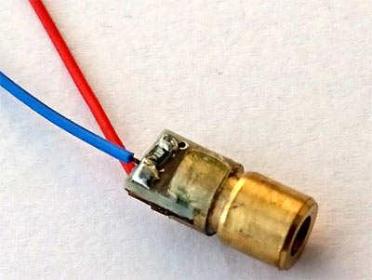

A Photoresistor (or light-dependent resistor, LDR, or photo-conductive cell) is a light-controlled variable [resistor](https://en.wikipedia.org/wiki/Resistor). The [resistance](https://en.wikipedia.org/wiki/Electrical_resistance) of a photoresistor decreases with increasing incident light intensity; in other words, it exhibits [photoconductivity](https://en.wikipedia.org/wiki/Photoconductivity). A photoresistor can be applied in light-sensitive detector circuits, and light-activated and dark-activated switching circuits.

A photoresistor is made of a high resistance [semiconductor](https://en.wikipedia.org/wiki/Semiconductor). In the dark, a photoresistor can have a resistance as high as several megohms (MΩ), while in the light, a photoresistor can have a resistance as low as a few hundred ohms. If incident light on a photoresistor exceeds a certain [frequency](https://en.wikipedia.org/wiki/Frequency), [photons](https://en.wikipedia.org/wiki/Photon) absorbed by the semiconductor give bound [electrons](https://en.wikipedia.org/wiki/Electron) enough energy to jump into the [conduction band](https://en.wikipedia.org/wiki/Conduction_band). The resulting free electrons (and their [hole](https://en.wikipedia.org/wiki/Electron_hole) partners) conduct electricity, thereby lowering [resistance](https://en.wikipedia.org/wiki/Electrical_resistance). The resistance range and sensitivity of a photoresistor can substantially differ among dissimilar devices. Moreover, unique photoresistors may react substantially differently to photons within certain wavelength bands.

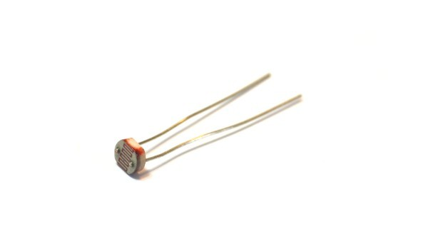

The fourteen holes on one of the longer faces of the 3d printed material are inserted with laser diodes. Similarly the five holes on one of the smaller faces of the 3d material are inserted with laser diodes. The holes on the faces parallel to the faces with laser diodes are inserted with Light Dependent Resistors(LDR’s). The laser diodes are given a voltage of 5V from any external supply or more efficiently from one of output ports of the NI My RIO processor.

PROCESSING MODULE

The processor used is NI MY Rio. The National Instruments myRIO-1900 is a portable reconfigurable I/O (RIO) device used to design control robotics and mechatronics system. The hardware is based on Xilinx Zynq-7010 with a dual-core ARM Cortex-A9 processor and an FPGA with 28,000 programmable logic cells, and features 10 analog inputs, 6 analog outputs, audio I/O channels, and up to 40 lines of digital input/output (DIO).

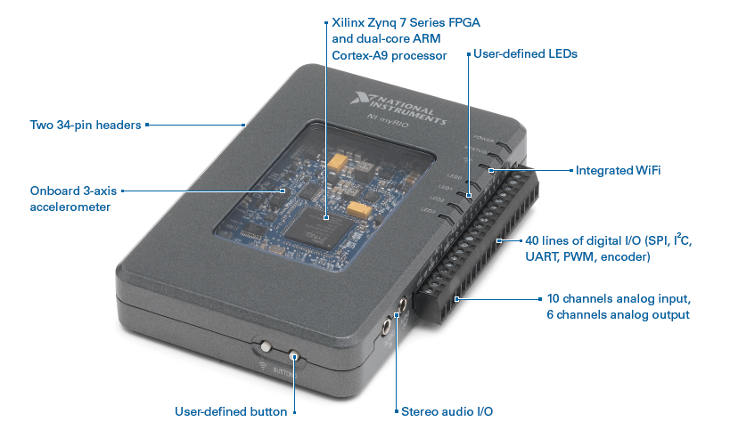

The NI myRIO-1900 provides analog input (AI), analog output (AO), digital input and output (DIO), audio, and power output in a compact embedded device. The NI myRIO-1900 connects to a host computer over USB and wireless 802.11b,g,n. NI myRIO is based on the same LabVIEW RIO architecture as NI's industrially used NI CompactRIO and NI Single-BoardRIO products. These products combine a processor, FPGA, and I/O, and are fully programmable with LabVIEW. In fact, NI myRIO uses the same Xilinx Zynq All-programmable SoC technology found in NI's newest CompactRIO, the cRIO-9068

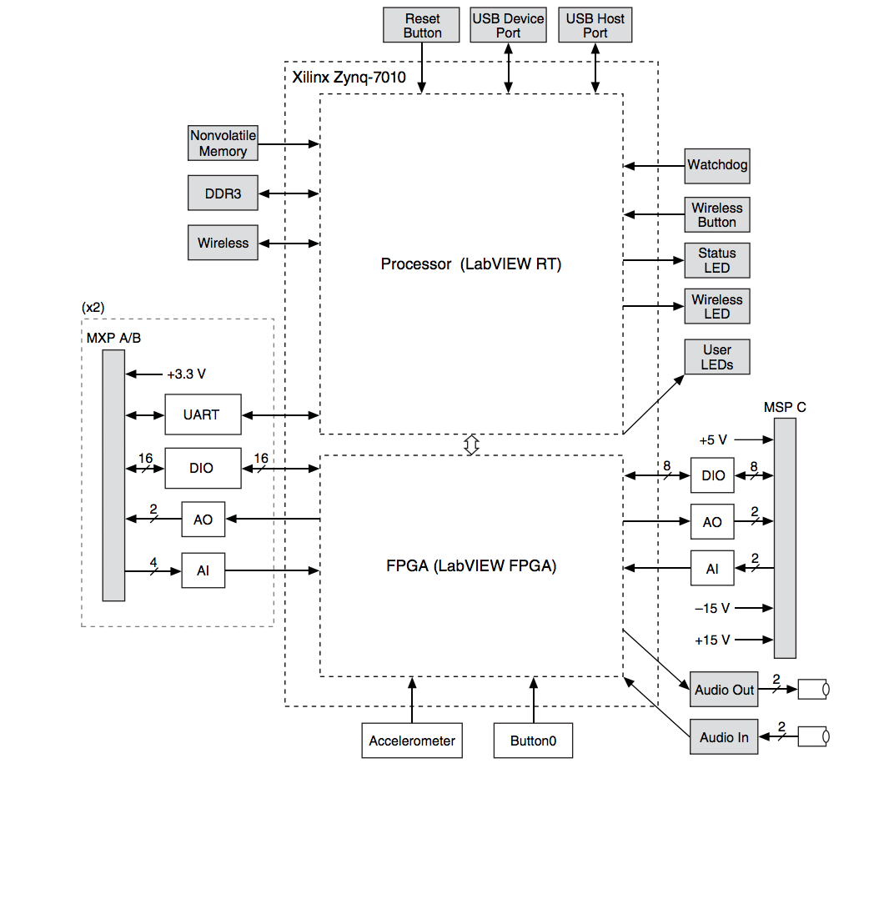

NI myRIO-1900 Hardware Block Diagram

NI ships the FPGA of myRIO pre-defined with AI, AO, PWMs, Quad Encoder inputs, UART, SPI. and2C.

NI myRIO-1900 Expansion Port (MXP) connectors A and B carry identical sets of signals. The signals are distinguished in software by the connector name, as in ConnectorA/DIO1 and ConnectorB/DIO1.

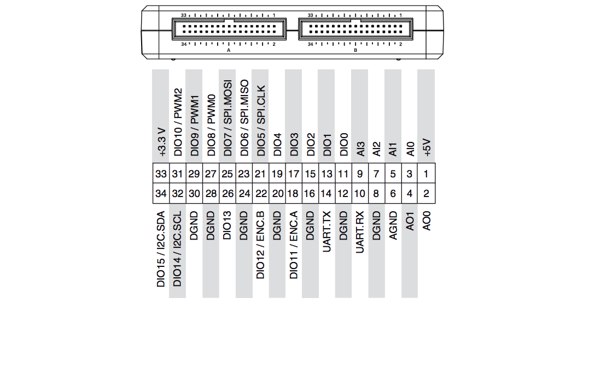

Primary/Secondary Signals on MXP Connectors A and B

|  |  |  |  |
| --- | --- | --- | --- |
| Signal Name | Reference | Direction | Description |
| +5V | DGND | Output | +5 V power output. |
| AI <0..3> | AGND | Input | 0-5 V, referenced, single-ended analog input channels. |
| AO <0..1> | AGND | Output | 0-5 V referenced, single-ended analog output. |
| AGND | N/A | N/A | Reference for analog input and output |
| +3.3V | DGND | Output | +3.3 V power output. |
| DIO <0..15> | DGND | Input or  Output | General-purpose digital lines with  3.3 V output, 3.3 V/5 compatible  input. |
| UART.RX | DGND | Input | UART receive input. UART lines are electrically identical to DIO lines. |
| UART.TX | DGND | Output | UART transmit output. UART lines are electrically identical to DIO lines |
| DGND | N/A | N/A | Reference for digital signals, +5 V, and +3.3 V  Description of signals on MXP Connectors A and B |

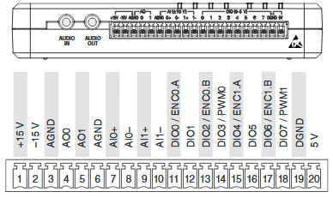

Primary/Secondary Signals on MSP Connector C

|  |  |  |  |
| --- | --- | --- | --- |
| Signal Name | Reference | Direction | Description |
| +15V/-15V | AGND | Output | +15 V/-15 V power output. |
| AI0+/AI0-;  AI1+/AI1- | AGND | Input | ±10 V, differential analog input channels |
| AO <0..1> | AGND | Output | ±10 V referenced, single-ended analog output channels |
| AGND | N/A | N/A | Reference for analog input and output and +15 V/-15 V power output. |
| +5V | DGND | Output | +5 V power output. |
| DIO <0..7> | DGND | Input or  Output | General-purpose digital lines with 3.3 V output, 3.3 V/5 compatible input. |
| DGND | N/A | N/A | Reference for digital signals, +5 Vpower output |

Descriptions of Signals on MSP Connector C

The following are the specifications of the NI myRIO 1900.

|  |  |
| --- | --- |
| Processor type | Xilinx Z-7010 |
| Processor speed | 667 MHz |
| Processor cores | 2 |
| Nonvolatile memory | 256 MB |
| DDR3 memory | 512 MB |
| FPGA type | 20 MHz |
| Radio mode | IEEE 802.11 b,g,n |
| Frequency band | ISM 2.4 GHz |
| Channel width | 20 MHz |
| TX power | +10 dBm max (10 mW) |
| Outdoor range | Up to 150m (line of sight) |
| Antenna directivity | Omnidirectional |
| Security | WPA, WPA2, WPA2-Enterprise |
| USB host port | USB 2.0 Hi-Speed |
| USB device port | USB 2.0 Hi-Speed |
| Analog Output Resolution | 12 bits |
| Analog Output Overload protection | ±16 V |
| MSP connector Configuration | Two single-ended channels |
| MSP connector range | ±10 V |
| MSP connector Absolute accuracy | ±200 mV |
| MSP connector Current drive | 2 mA |
| MSP connector Slew rate | 2 V/μs |
| MXP connectors Configuration | Two single-ended channels per connector |
| MXP connectors Range | 0 V to +5 V |
| MXP connectors Absolute accuracy | 50 mV |
| MXP connectors Current drive | 3 mA |
| MXP connectors Slew rate | 0.3 V/μs |
| Audio output Configuration | One stereo output consisting of  two AC-coupled, single-ended channels |
| Audio output Output impedance | 100Ω in series with 22μF |
| Audio output Bandwidth | 70 Hz to >50 kHz into 32Ω load;2 Hz to >50 kHz into high impedance load |
| Number of Digital I/O lines MXP connectors | 2 ports of 16 DIO lines (one port per connector);one UART.RX and one UART.TX line per connector |
| Number of Digital I/O lines MSP connector | 1 port of 8 DIO lines |
| Direction control | Each DIO line individually programmable as input or output |
| Logic level | 5 V compatible LVTTL input; 3.3 V LVTTL output |
| Minimum pulse width | 20 ns |
| Maximum frequencies for SPI | 4 MHz |
| Maximum frequencies for PWM | 100 kHz |
| Maximum frequencies for Quadrature encoder input | 100 kHz |
| Maximum frequencies for I2C | 400 kHz |
| UART lines Maximum baud rate | 230,400 bps |
| UART lines Data bits | 5, 6, 7, 8 |
| UART lines Stop bits | 1, 2 |
| UART lines Parity | Odd, Even, Mark, Space |
| UART lines Flow control | XON/XOFF |
| Number of axes in Accelerometer | 3 |
| Accelerometer Range | ±8 g |
| Accelerometer Resolution | 12 bits |
| Accelerometer Sample rate | 800 S/s |
| Accelerometer Noise | 3.9 mg rms typical at 25 °C |
| +5 V power output-Output voltage | 4.75 V to 5.25 V |
| +5 V power output -Maximum current on each connector | 100 mA |
| +3.3 V power output-Output voltage | 3.0 V to 3.6 V |
| +3.3 V power output -Maximum current on each connector | 150 mA |

The NI myRIO microcontroller is programmed with a lab view code to differentiate the position of key presses. LabVIEW is different from most other general-purpose programming languages in two major ways. First, G programming is performed by wiring together graphical icons on a diagram, which is then compiled directly to machine code so the computer processors can execute it. G code developed with LabVIEW executes according to the rules of data flow instead of the more traditional procedural approach. It promotes data as the main concept behind any program. Dataflow execution is data-driven, or data-dependent. The flow of data between nodes in the program, not sequential lines of text, determines the execution order. There are 14 lasers on one of the longer side no of the cubical input module and 5 lasers on one of the shorter ones. They are inserted through the holes. On the other two sides which are parallel where lasers are kept, Light dependent resistors are placed. Thus forming a two dimensional matrix 5*14.

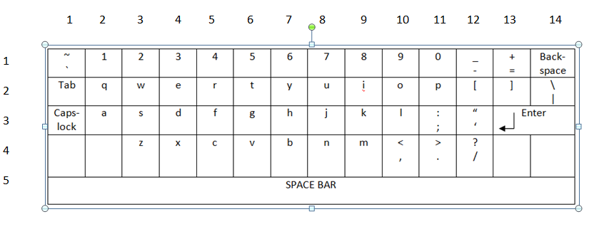

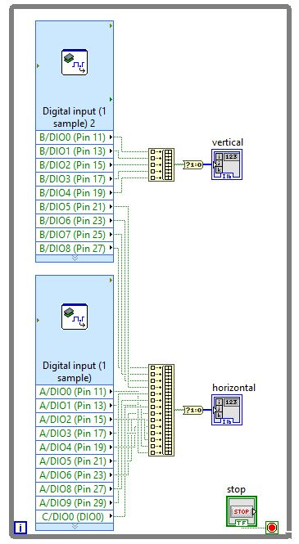

First the VI specific to myRIO is used to get the data at that instant. The whole workflow is placed in a while loop so that data will be collected repeatedly at every instant. If this data input is taken individually and processed repeatedly, it will consume lot of time and is less efficient. Hence the data is taken into arrays to save memory and improve processing of data. The program takes the input as the corresponding co ordinate on the matrix that identifies a key press. Two arrays, one for horizontal rows and another for vertical columns are used to get data in rows and columns. The program thus takes the input as the corresponding co ordinate on the matrix that identifies a key press. Pins in ports A, B and C are used as pull up transistors to carry the signal to the microcontroller from the light dependent resistors. A threshold is fixed to differentiate between key press and idle state. During the idle state i.e. when the light falls on the light dependent resistor (LDR), the voltage across LDR is more than 3 volts which is considered as logic ‘1’ and key detection is not identified. During the key press, the light energy from laser diode is blocked then the voltage across LDR will be less than 3 volts and the co responding array co ordinate for the horizontal row array and vertical column array changes to logic “0”. The array co ordinates are taken as variables as “x” and “y”.

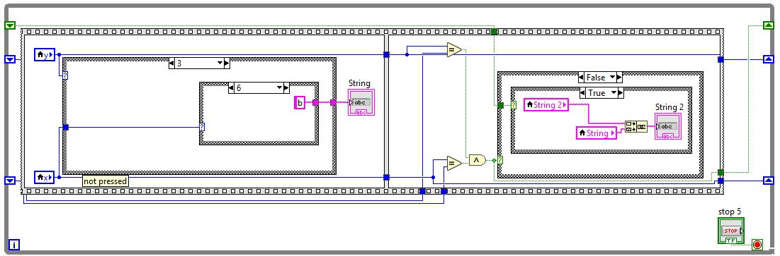

In this part of the code, every key in the keyboard is mapped to all the values of x and y with the help of nested switch statements. The same logic is used to concatenate all the key press to form a single string.

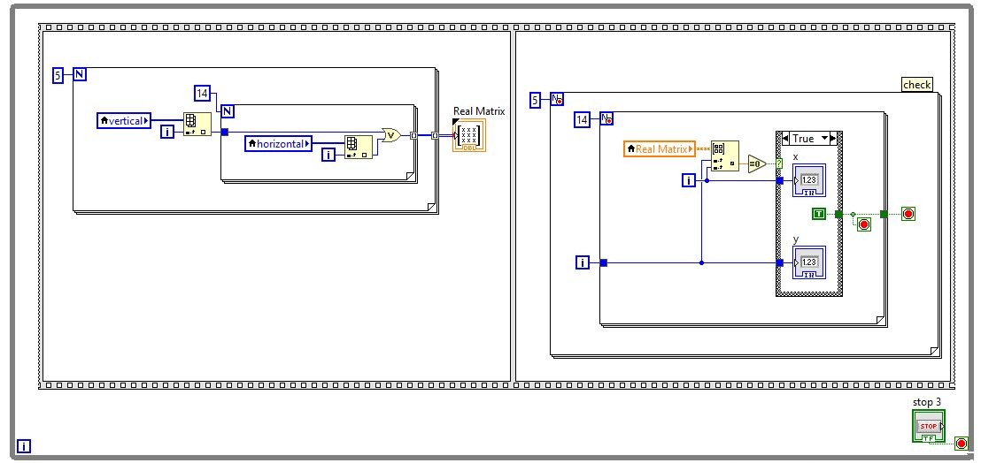

This part of the code is to convert the single dimension arrays into a matrix ( two dimensional array). We use a element selector to get the individual elements from the two arrays and place them in the matrix (i.e) zeroth index of the two arrays are placed in (0,0) position of the matrix. To take all the elements one at a time, we use nested for loops to get the elements and fill the matrix completely. The next set of nested for loops is used to take the x and y values to map the individual keys.

V keyboard test suite

The efficiency in the functioning of the keyboard is tested by identifying the detail of the factors which contribute to it. These factors are keyboard response time and key accuracy.

Keyboard Response time:

Keyboard response time represents the time requirement in milliseconds by the keyboard to capture the key press and display the corresponding character on the screen. In case of normal keyboard, the response time is a factor of the key debounce response, the scan rate, the internal CPU translation, the signaling speed, the interrupt latency of the main computer and the driver code. If the keyboard responds too slowly, it can turn the simplest of typing tasks into a misery. When tapping away at a keyboard the words on the screen should appear at a steady speed. But it’s not uncommon for keyboard response times to lag behind the typing skills of faster writers, or to outpace those needing more time to adjust to learning a new keyboard. Thus keyboard response time plays a crucial role in determining the better functioning of any keyboard.

Here a testing process is employed to identify the keyboard response time. The testing process involves subtracting the timestamp values at the position of the code, where the input is taken and another time stamp at the position of the code where the key is displayed. Since it is a virtual keyboard the debouncing criteria is not applicable but additionally the lab view code pipeline execution time itself will add up to the keyboard response time.

|  |  |
| --- | --- |
| Trials | Keyboard response time (in milliseconds) |
| Trial 1 | 6 |
| Trial 2 | 8 |
| Trial 3 | 12 |
| Trial 4 | 9 |
| Trial 5 | 8 |

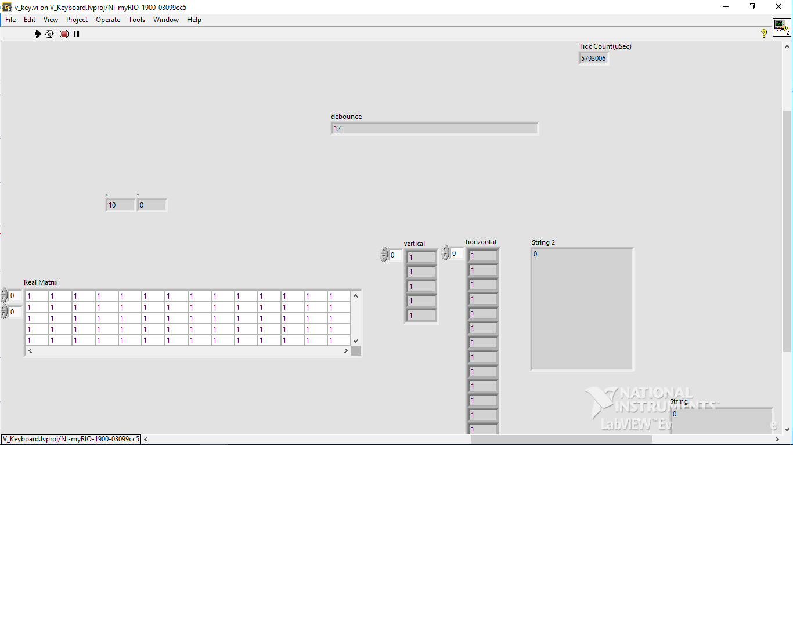

Screenshot of Keyboard response time test

Our proposed Virtual keyboard achieves a maximum keyboard response time of 12 ms and on average response time of 8.6 ms.

Key accuracy:

Virtual keyboards are vulnerable to “key stroke deviations”. There are different ways keystroke deviation may occur. When we strike the keyboard in high frequency, the keystroke is easy to deviate. Repeated striking of the same key results in unexpected recognition due to deviations. Thus users cannot get the feedback just as striking a real keyboard. If the finger tip almost falls in the expected key stroke position, the result turns out to be more accurate. When the finger tip falls in the position between the two keys, it might results in erroneous key recognition. Another testing process is employed to arbitrarily identify the accuracy of key recognition. Keys are selected at random and are typed repeatedly and then the key recognition statistics is collected. This is repeated for single characters (number, letter, space) and multiple characters.

|  |  |  |
| --- | --- | --- |
| Character | No of trials | Accuracy=(Number of success trials/total number of trials)*100% |
| “a” | 20 | 100% |
| “y” | 20 | 100% |
| “r” | 20 | 100% |
| “8” | 20 | 100% |
| “1” | 20 | 100% |
| “pqr” | 20 | 90% |
| “501” | 20 | 95% |
| Space bar | 20 | 100% |

The accuracy of the key recognition can be increased by optimizing the alignment of lasers and Light dependent Resistors.